

Robert Gordon University

Games Prototyping

Ronnie Neri

2210226

Class CM3133

Games Prototyping Documentation and User Testing

This report is my documentation throughout my plans of the game project, and I will keep updating the report upon testing. I will be writing down all my ideas and thoughts of how I want the game to look like and what type of features I want in the game. There is a surprise I want to implement at the end, would be fun to try out the game first to see the surprise scene.

Tables of Contents

Page 4……………………………………………………………………………………………….. Gantt Chart, Ideas and Designs

Page 5…………………………………………………………………………………………….. Games Influencing my Decisions

Page 6-7…………………………………………………………………………………………..………Assets and Storyboard Ideas

Gantt Chart

My weekly plan of how this project will be managed to meet deadline date. I will invest my time learning how to create the game as it is my first time using Unity as well as going into C#. My knowledge of coding is very minimal so I will spend a lot of my weeks learning how to do certain things to achieve the game that I want to make. I will make sure I have enough time to create my game and make sure it works as intended.

Ideas and Designs

The idea that I will be going for is a maze like game. I enjoyed playing maze games as a kid and I want to be able to learn how to make the games I used to enjoy in my childhood. Maze games that can be fairly hard to go through levels is what I find fun such as having obstacles blocking the path to the goal or having to figure out the specific path to reach the goal. This will also be easy to implement and very doable to reach the project deadline.

Games Influencing my Decisions

Games that really influenced my decision into making a maze game is a game I loved playing with my friends called ‘Scary Maze’ and ‘Pac Man’. These 2 games have a simple design and idea but was fun and made a lot of memories playing them with friends. Scary Maze has the features and design that is easy to make and doable for someone who is new to Unity. Creating the assets should be minimal allowing me to be able to expand my knowledge more into learning how to use the software and code. Pac Man has some features I want to use such as enemies and blocking paths for the player, I also like the feature where the enemy would follow the player using smart AI to kill the player. The difficulty of Pac Man has a good pace, simple but difficult due to the smart AI implemented as well as having to think of ways to collect points efficiently.



Assets and Storyboard Ideas

The idea of my head is having an apple protagonist trying to survive through worms and spiders and reach the apple tree to be with his kind. He will have to go through a series of bushes and finding a way to the tree and along the way will be worms looking for food to feast in. A spider is also chasing after the apple to eat him too. There will be multiple assets used, primarily 5 consistent assets that are visible to the users. Visible Assets are:

Tree – End of the scene – When player reaches tree, the tree will change the scene to the next scene.

Bushes – Blocks pathway to the goal – Wall collider will keep player from going through the bushes to increase level difficulty.

Apple – Player controller character – Can be killed. When killed, player will spawn particles upon death and a UI will appear to either restart or go to main menu. Player must reach the goal to win complete the scene.

Worms – Follows through a pathway to block player from advancing. Colliding with worms will cause player death – Worms follow a scripted path that allows them to rotate and loop the pathway points.

Spider – Spider is scripted with smart AI following the player after some time has passed. The player must reach the goal before the spider eats him – Spider is scripted with a smart AI that rotates their body to look and go towards the player. The spider will have a kinematic rigidbody to allow them to go through box colliders and will react as an enemy collider upon player contact.

Intro – Image/background for introduction scene that the user can either start or quit the game.

Secret Assets – Video and audio for intended purpose in final scene - Scene will lead you back to main menu to finish the game.

Leaves – Particle effect that drops leaves from the top for aesthetic purposes.

Blood particles and Trail – particle effect upon death. Player also leaves a trail

There are some hidden assets that the player can not see, primarily box collision so player does not leave the scene and music.

Buttons are within the Canvas that are scripted to restart the scene or go to main menu. Buttons and text are customised to fit the game theme.

In this storyboard, the red is the player going through multiple different type of obstacles going difficult after every scene. The black lines and boxes are the obstacles and more appears each scene. There will be worms, spiders, trees and bushes in every scene. Spiders and worms will attempt to kill player. Any collision with any of them will result in death.

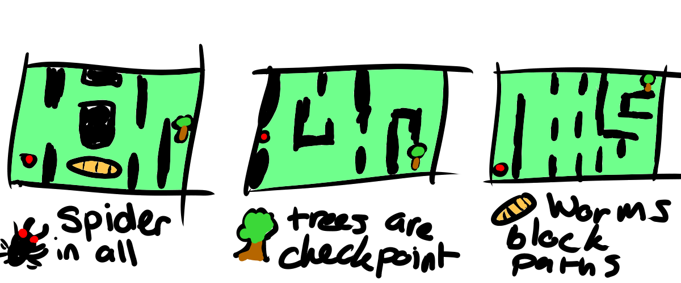

(Spider in All) (Trees are checkpoint) (Worms block paths)

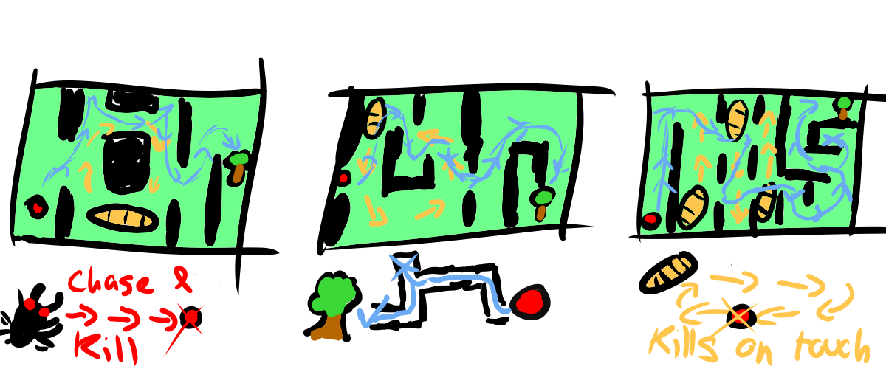

UI mockup storyboards are ideas of how I want how I want my UI to look like. These UIs are easy and doable to produce within the game. Buttons will be scripted to the correct scenes intended for the buttons and will make sure it is tested thoroughly. Will have to learn how to switches to specific scenes for all the buttons to work.

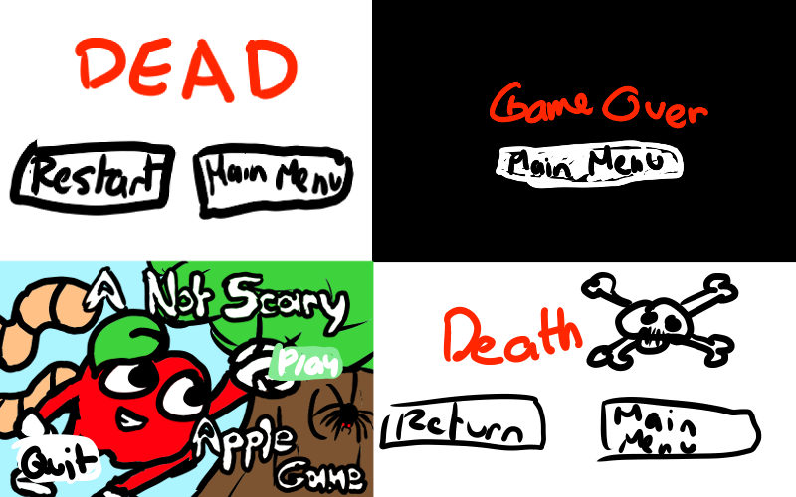

Testing

Testing the game has been bothersome. I had many problems I had to fix in order for my game to work the way I wanted it. These problems are:

1. Main Camera Position - Within unity, the main camera changes randomly when you change the window/taskbar sizes making it unreliable to use as a guideline. I had to reposition all the scenes multiple times to ensure player stays within the scene.
2. Buttons – Some restart buttons were not synchronised to the correct scenes, I had to change the script in order to do so. Another problem was that the main menu button upon death did not disappear while player was alive. I successfully went back to the player script to make the button (false) in order for it to disappear when alive and reappear upon death.
3. Spider – Spider chases too fast, had to change spider position further in order for them to reach player longer.
4. Music – Music stopped after every scene. Made a separate script to constantly play music throughout all the screens. I also had to learn to stop the music on the last scene.
5. Blood Particles – Blood particles appear on the scene, I had to reposition it outside the scene box.
6. Box Colliders – Worms pushed player back due to not identifying them as enemies. I changed worm tag to enemy to trigger player death.

In conclusion, the project was really fun to make. Learning new skills and expanding my knowledge on something fresh was enjoyable to do. Having the freedom to create what I wanted give me possibilities to find creative ways to make the game interesting features such as the trail features or making the pathway for the worms.